EXP NO: 1
Estimation of Characteristic Impedance (Zo), and Propagation Constant (γ) of a Transmission Line from Primary Constants.
Test Case 1:
Investigating the significance of Characteristic Impedance (Zo), and Propagation Constant
(γ) of a Transmission Line using the following parameters
Code:
clear; clc;
R=10;L=0.003;f=2*10^3;G=4*(10^-6);C=16*(10^-6);
w=2*%pi*f;
Z=R+(%i*w*L);
Y=G+(%i*w*C);
Zo=sqrt(Z/Y);
C=round(real(Zo));
D=round(imag(Zo));
printf('-Zo = %f + j(%f)ohms\n',C,D);
P=sqrt(Z*Y);
a=real(P);
a1=round(a*10000)/10000;
printf('-Attenuation constant a = %f neper/km\n',a1);
b=imag(P);
b1=round(b*10000)/10000;
printf('-Phase constant b = %f radians/km',b1);
OUTPUT:
Simulation results |  |  | Theoretical results
Z0(ohms) | α(neper/km) | β(radians/km) | α(neper/km) | β(radians/km)
 | 0.33 | 2.99 | 0.2378 | 4.421

THEORETICAL RESULTS:
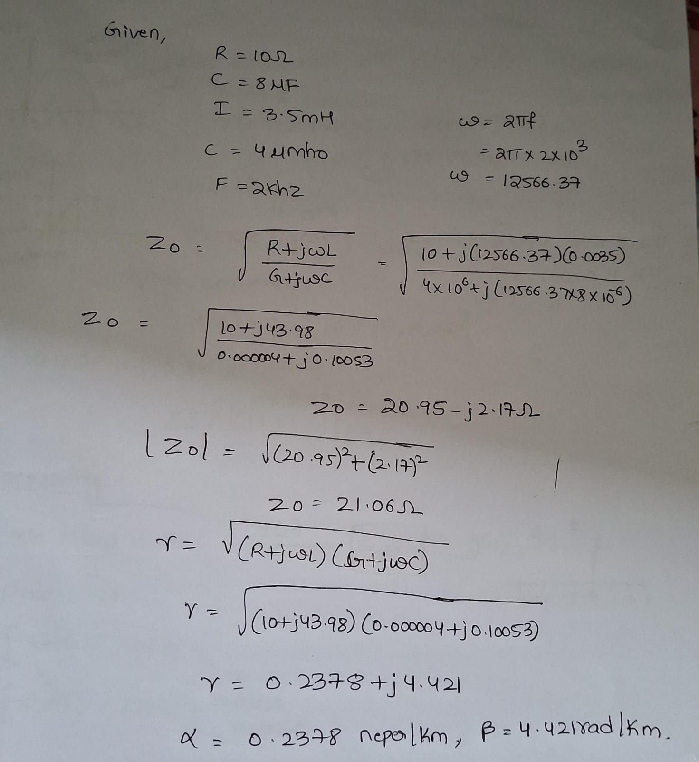

SIMULATION RESULTS:

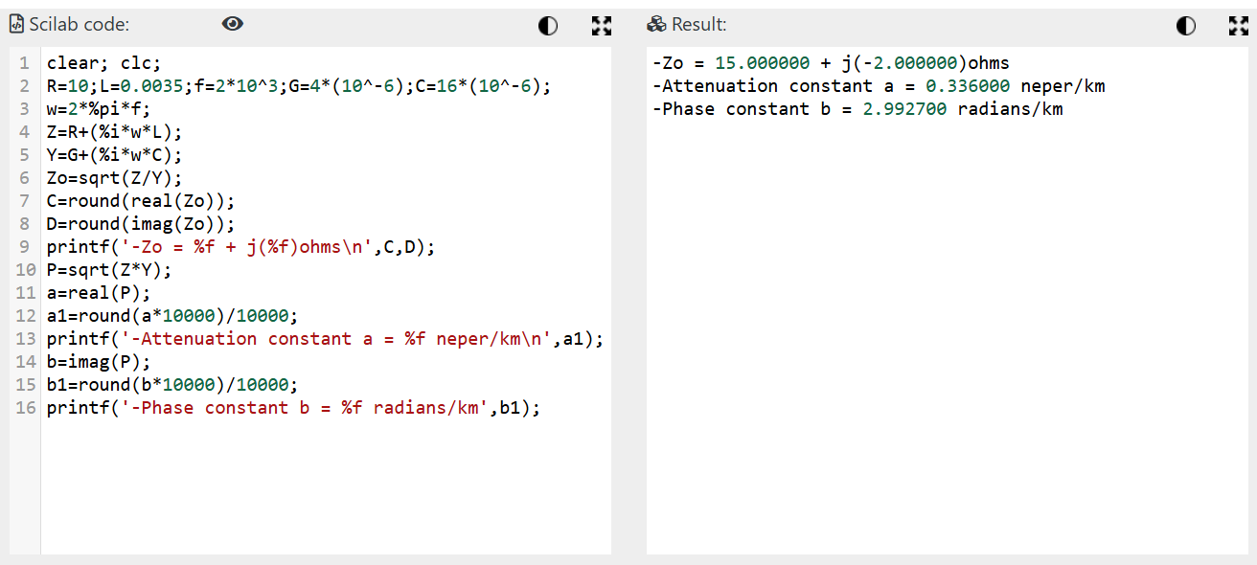

TEST CASE 2:
Examine the impact of resistance and inductance on the significance of Characteristic Impedance (Zo) and Propagation Constant (γ) of a Transmission Line at a frequency f=2.5 Khz. Vary the resistance value from 10 Ω to 50 Ω at the interval of 10 Ω with L,G and Cvalues constant and calculate the Characteristic Impedance and Propagation Constant .Vary the inductance values from 3.5 mH to 11.5 mH at the interval of 2.5 mH with R,G and C values constant.

PROGRAM:
clear; clc;
R=10;L=0.003;f=2*10^3;G=4*(10^-6);C=16*(10^-6);
w=2*%pi*f;
Z=R+(%i*w*L);
Y=G+(%i*w*C);
Zo=sqrt(Z/Y);
C=round(real(Zo));
D=round(imag(Zo));
printf('-Zo = %f + j(%f)ohms\n',C,D);
P=sqrt(Z*Y);
a=real(P);
a1=round(a*10000)/10000;
printf('-Attenuation constant a = %f neper/km\n',a1);
b=imag(P);
b1=round(b*10000)/10000;

OUTPUT:
Variable R
Constants L=3mH; f=2000; G=.4*(10^-6); C=8*(10^-6).

S.No | (R) (Ω) | Theoretical (Z_0) (Ω) | Theoretical α | Theoretical β | Simulation α | Simulation β
1 | 10 | 19.53 − j2.546 | 0.2560 | 1.9635 | 0.2560 | 1.9635
2 | 20 | 19.994 − j4.975 | 0.5002 | 2.0100 | 0.5002 | 2.0100
3 | 30 | 20.667 − j7.220 | 0.7258 | 2.0777 | 0.7258 | 2.0777
4 | 40 | 21.468 − j9.267 | 0.9316 | 2.1582 | 0.9316 | 2.1582
5 | 50 | 22.337 − j11.133 | 1.1192 | 2.2456 | 1.1192 | 2.2456

Variable L
Constants R=10Ω; f=2000; G=.4*(10^-6); C=8*(10^-6).
S.No | (L) (mH) | Theoretical (Z_0) (Ω) | Theoretical α | Theoretical β | Simulation α | Simulation β
1 | 3.5 | 21.050 − j2.363 | 0.2375 | 2.1161 | 0.2375 | 2.1161
2 | 8 | 31.662 − j1.571 | 0.1579 | 3.1830 | 0.1579 | 3.1830
3 | 6 | 27.446 − j1.812 | 0.1822 | 2.7592 | 0.1822 | 2.7592
4 | 11 | 37.105 − j1.340 | 0.1348 | 3.7302 | 0.1348 | 3.7302
5 | 11.5 | 37.937 − j1.311 | 0.1318 | 3.8138 | 0.1318 | 3.8138

SIMULATION RESULT:
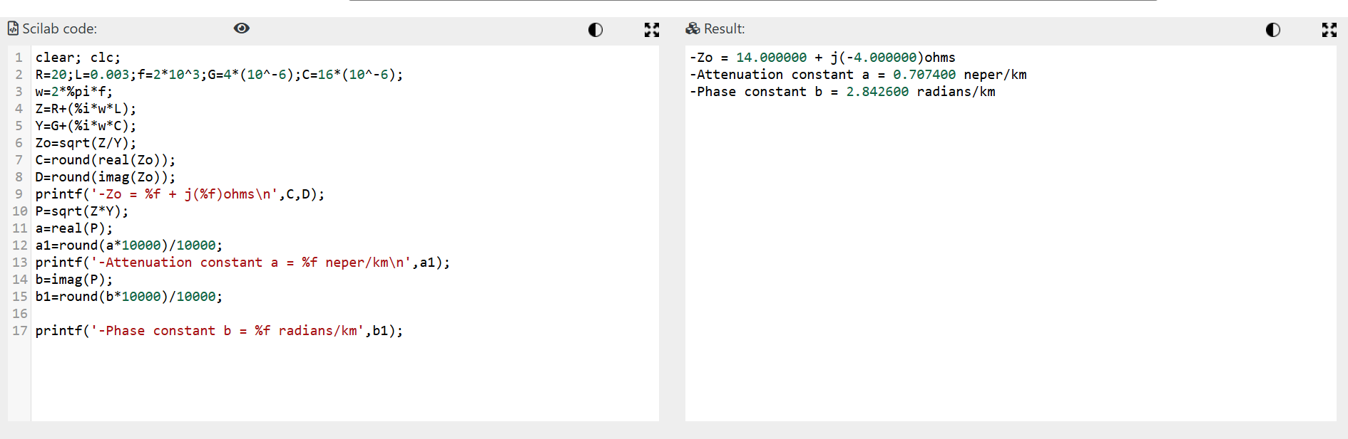

THEORETICAL RESULT: 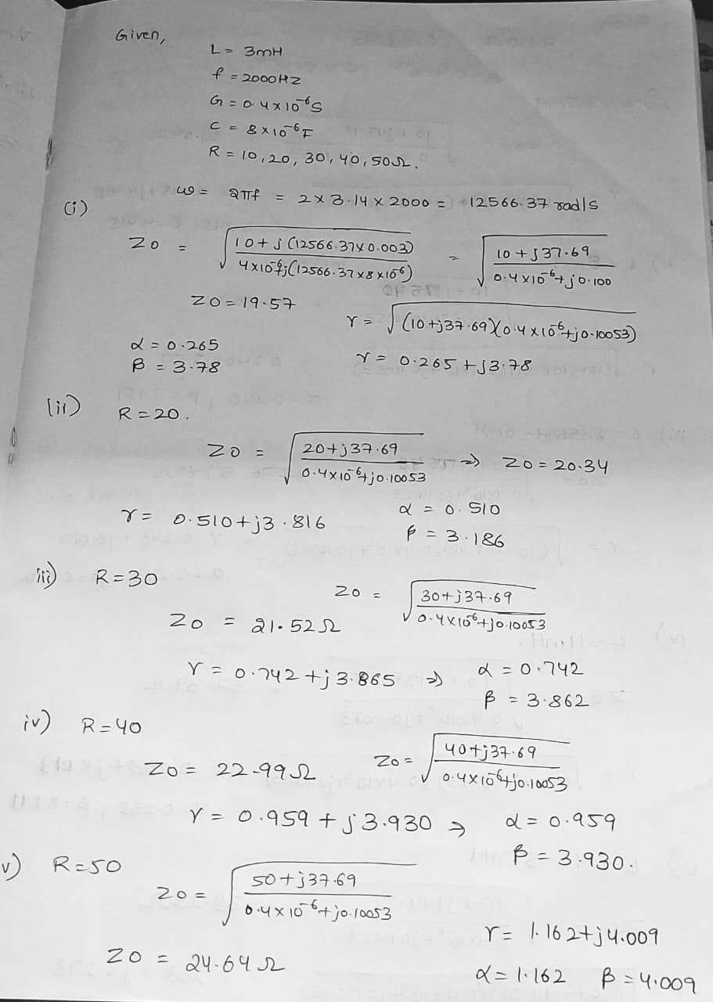
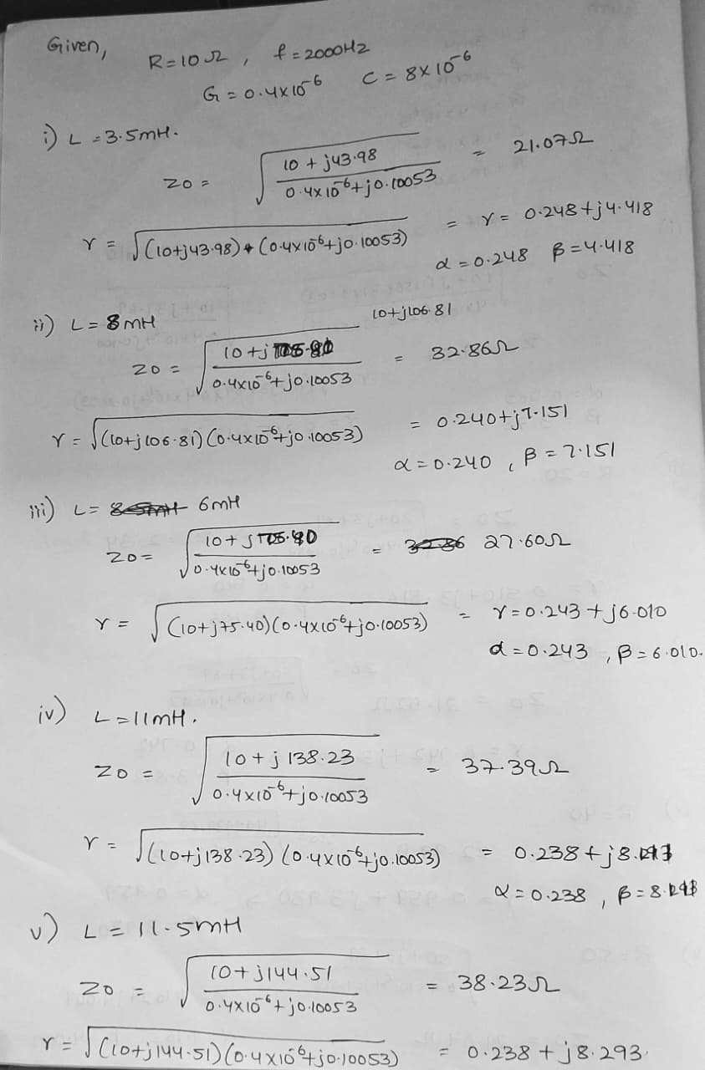
Test Case 3:
Explore the impact of frequency and capacitance on the significance of Characteristic
Impedance (Zo) and Propagation Constant (γ) of a Transmission Line. Vary the frequency
from 2KHz to 10 KHz at the interval of 2 KHz with L,R ,G and C values constant and
calculate the Characteristic Impedance and Propagation Constant . Vary the capacitance
values from 8 μF to 16 μF at the interval of 2 μF with R,G and L values constant.

OUTPUT:
Variable f
Constants L=3mH; f=2000; G=.4*(10^-6); C=8*(10^-6).
S.No | Input (f) (KHz) | Theoretical (Z_0) (Ω) | Theoretical α (neper/km) | Theoretical β (rad/km) | Simulation α (neper/km) | Simulation β (rad/km)
1 | 2 | 19.532 − j2.546 | 0.2560 | 1.9635 | 0.2560 | 1.9635
2 | 4 | 19.407 − j1.281 | 0.2576 | 3.9021 | 0.2576 | 3.9021
3 | 6 | 19.384 − j0.855 | 0.2580 | 5.8460 | 0.2580 | 5.8460
4 | 8 | 19.376 − j0.642 | 0.2581 | 7.7914 | 0.2581 | 7.7914
5 | 10 | 19.372 − j0.513 | 0.2581 | 9.7373 | 0.2581 | 9.7373
Variable c
Constants R=10Ω; f=2000; G=.4*(10^-6); C=8*(10^-6).
S.NO | INPUT (C) (μF) | Theoretical (Z_0) (Ω) | Theoretical α | Theoretical β | Simulation α | Simulation β
1 | 8 | 19.532 − j2.546 | 0.2560 | 1.9635 | 0.2560 | 1.9635
2 | 10 | 17.470 − j2.278 | 0.2862 | 2.1953 | 0.2862 | 2.1953
3 | 12 | 15.948 − j2.079 | 0.3135 | 2.4048 | 0.3135 | 2.4048
4 | 14 | 14.765 − j1.925 | 0.3387 | 2.5975 | 0.3387 | 2.5975
5 | 16 | 13.811 − j1.801 | 0.3620 | 2.7769 | 0.3620 | 2.7769

SIMULATION RESULT:
